**Foundation**

SQL

Module 10

Subqueries (part 2) – Query reading

© FDM Group Ltd 2017. All Rights Reserved.

Any unauthorised reproduction or distribution in part  
or in whole will constitute an infringement of copyright.

**Document change and version control**

|  |  |  |  |
| --- | --- | --- | --- |
| **Reason for Change** | **Author** | **Date of Change** | **New Version No** |
| Creation of document | Nick Lawton | 26/06/2017 | v1.0 |
|  |  |  |  |
|  |  |  |  |
|  |  |  |  |
|  |  |  |  |
|  |  |  |  |
|  |  |  |  |
|  |  |  |  |
|  |  |  |  |
|  |  |  |  |
|  |  |  |  |
|  |  |  |  |

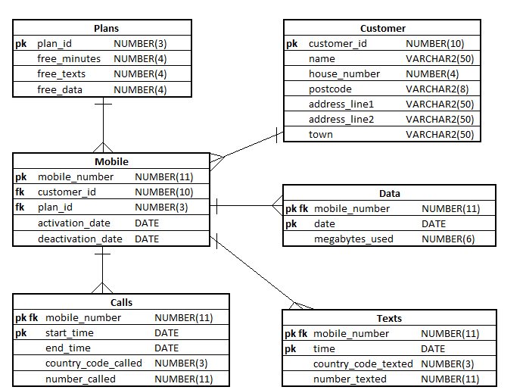

**Exercise 1**

## Describe in simple language what each of the following queries will return.

## Some of the queries will produce an error.

## Some will produce meaningless information. Explain which is which.

|  |
| --- |
| **Questions** |
| 1. SELECT mobile_number   FROM mobile  WHERE activation_date =  (  SELECT MAX(deactivation_date)  FROM mobile  );  This will have an error,  MAX(deactivation_date) is different from activation_date, so they can’t equal. |
| 1. SELECT mobile_number   FROM calls  WHERE start_time =  (  SELECT MIN(start_time)  FROM calls  );  The earliest start time for calls from a single mobile number (from list of mobile numbers)  Should work |
| 1. SELECT plan_id   FROM plans  WHERE free_minutes =  (  SELECT MAX(free_minutes)  FROM plans  ) ;  Show the plan id with the largest free minutes plan  Should work |
| 1. SELECT name   FROM customer  WHERE customer_id =  (  SELECT customer_id,  COUNT(customer_id)  FROM mobile  GROUP BY customer_id  );  Error  There is no group by in the first select so the number of columns in both are not the same  First : two non aggregates  Second: one aggregate and one non aggregate |